**Merge Without Extra Space**

**First Approach -> Extra Array of size n1+n2**

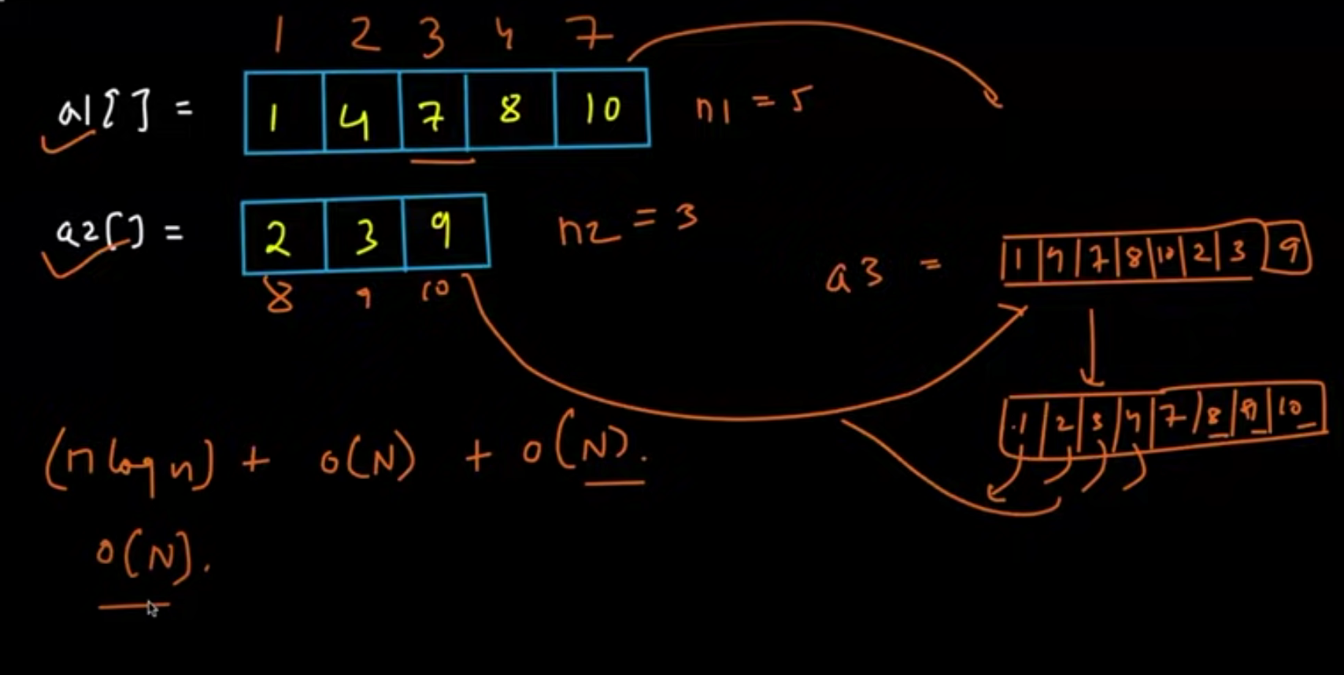

Second Approach -> Continue swap and reorder a2

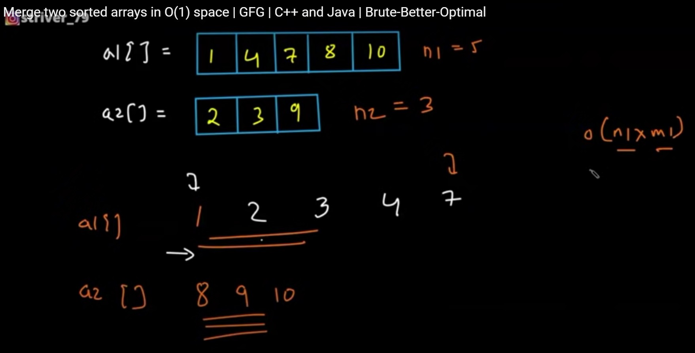

Third Approach -> Gap Pointer -> Compare within a gap

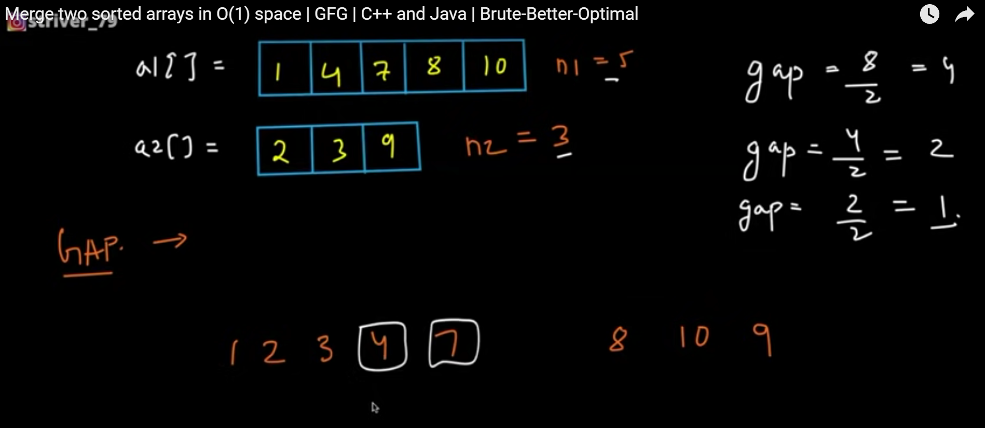

class Solution {

public:

void merge(vector<int>& nums1, int m, vector<int>& nums2, int n) {

int i=m-1;

int j=n-1;

int k=m+n-1;

while(i>=0 && j>=0){

if(nums1[i]>nums2[j]){

nums1[k]=nums1[i];

i--;

k--;

}

else{

nums1[k]=nums2[j];

j--;

k--;

}

}

while(i>=0)

nums1[k--]=nums1[i--];

while(j>=0)

nums1[k--]=nums2[j--];

}

};

**3 SUM PROBLEM -> TWO POINTER APPROACH**

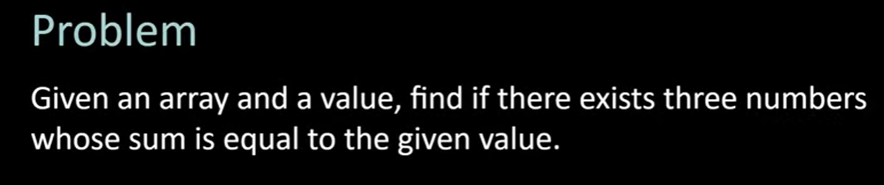

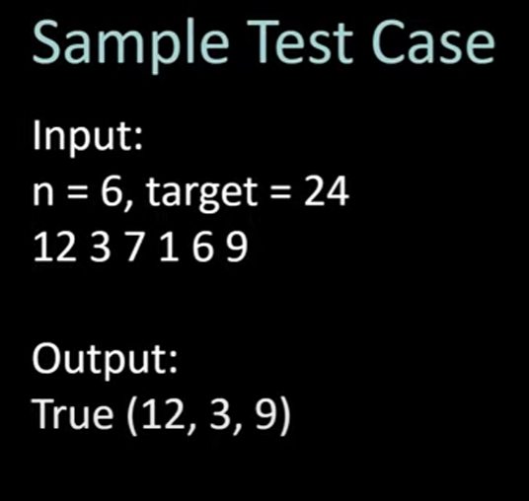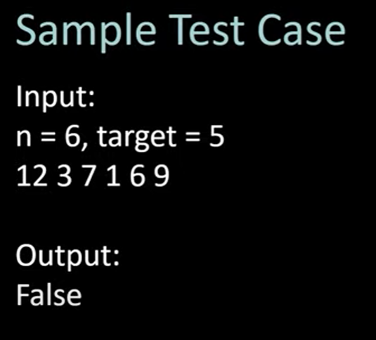

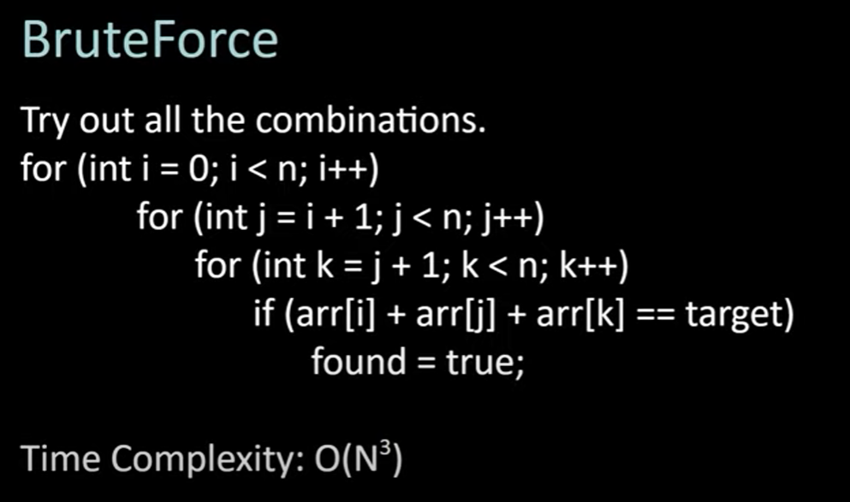

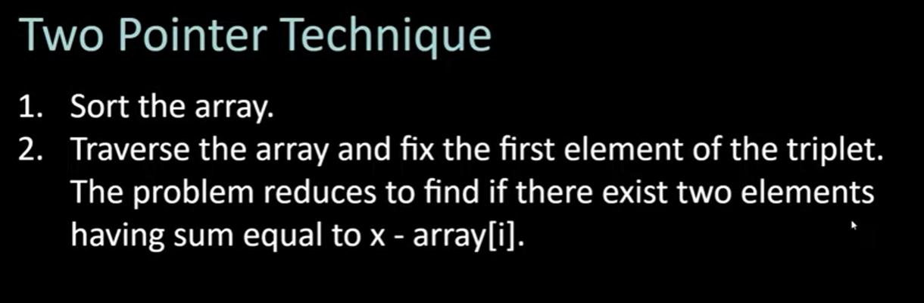

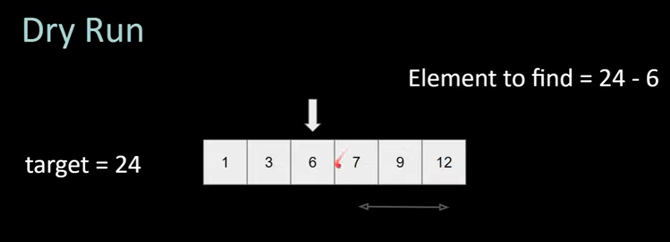

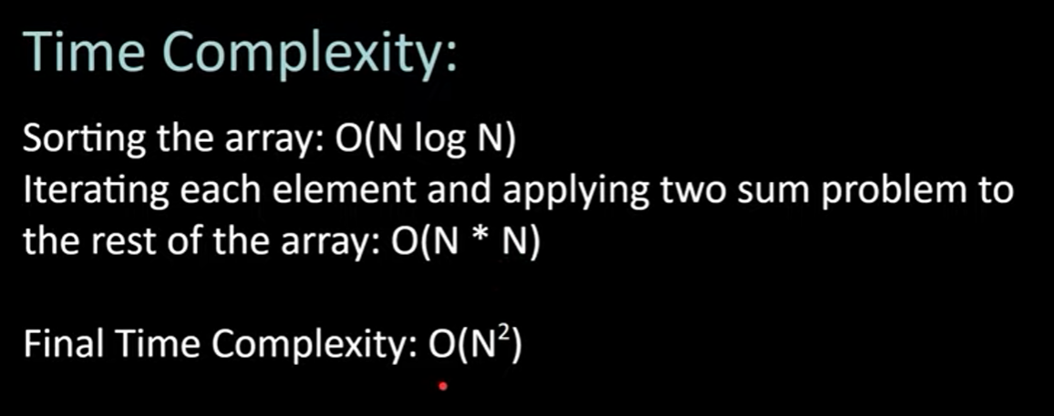

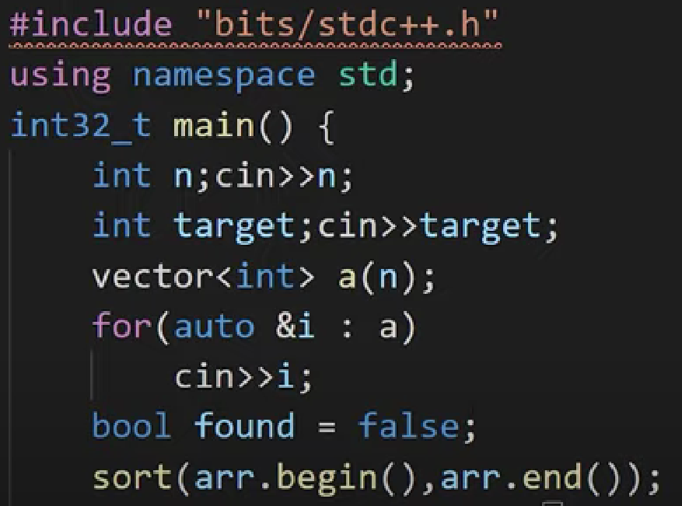

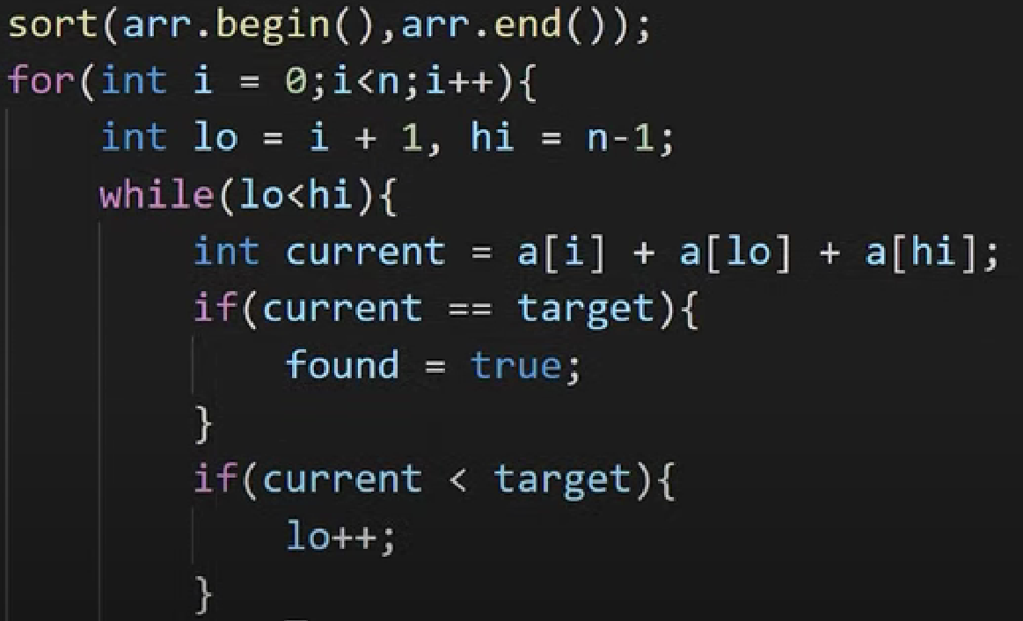

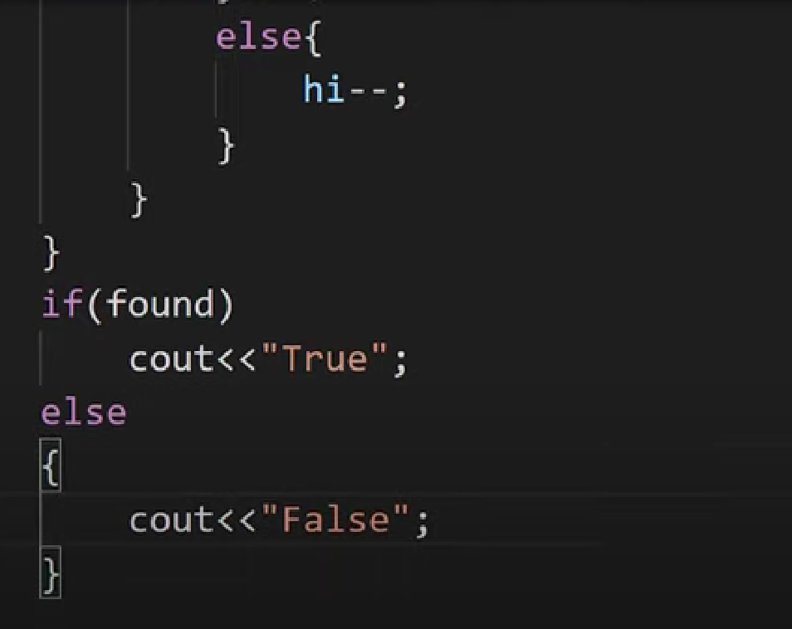

**Two pointer Approach -> Fix pointer at start + end -> and execute in single while loop ->value = low then start++ -> value = high then end—**

**Merge Intervals**

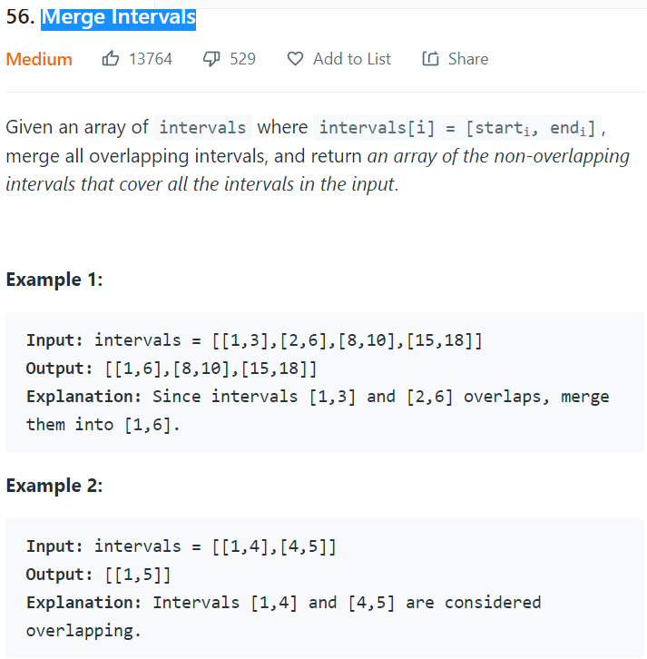

**Approach 1**

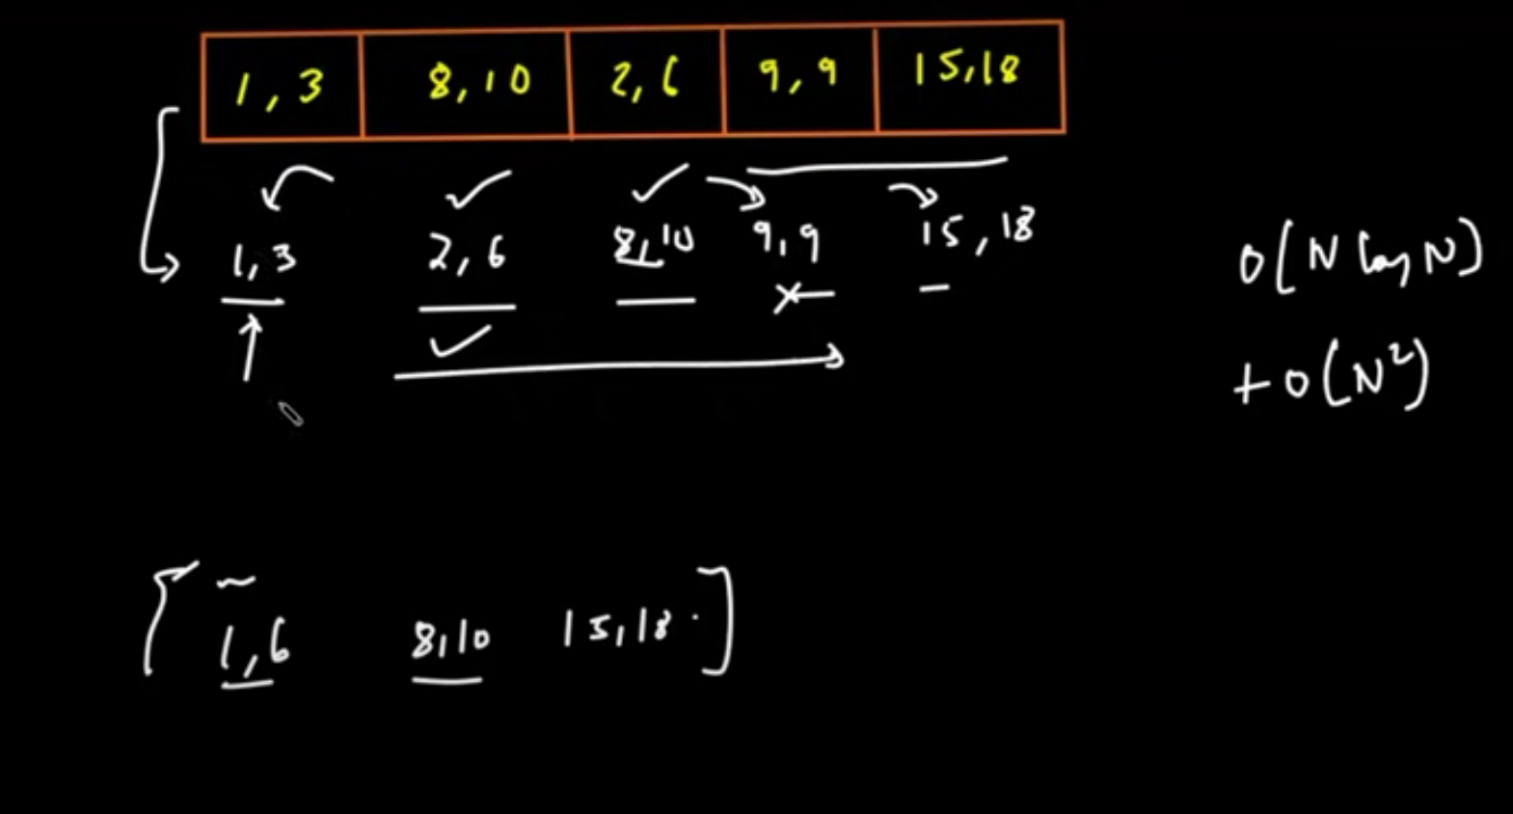

Approach 2

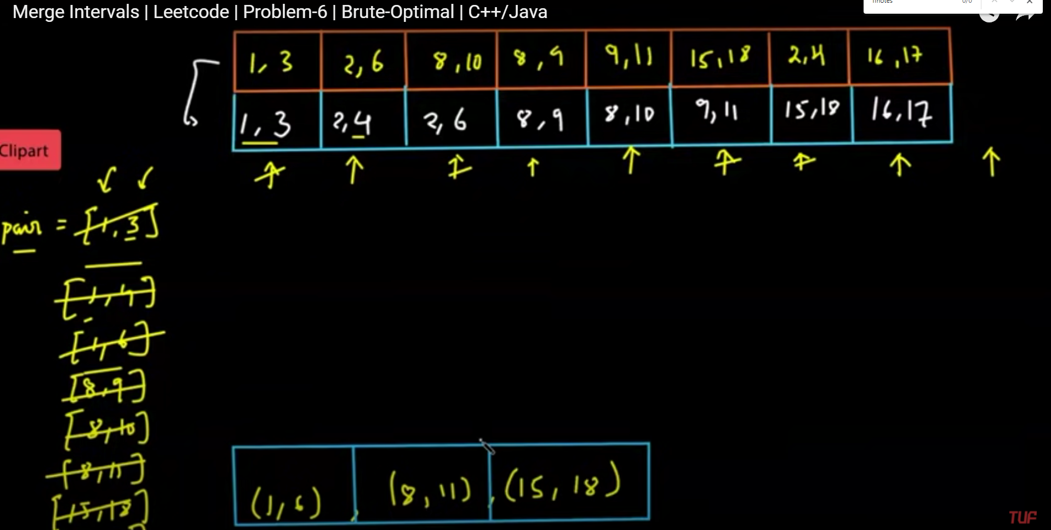

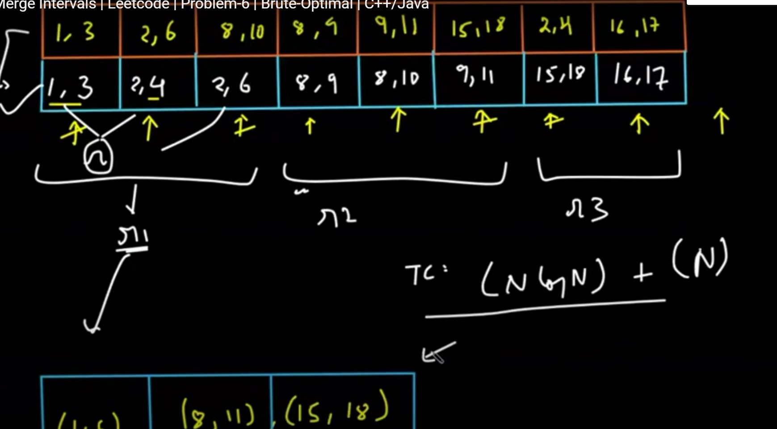

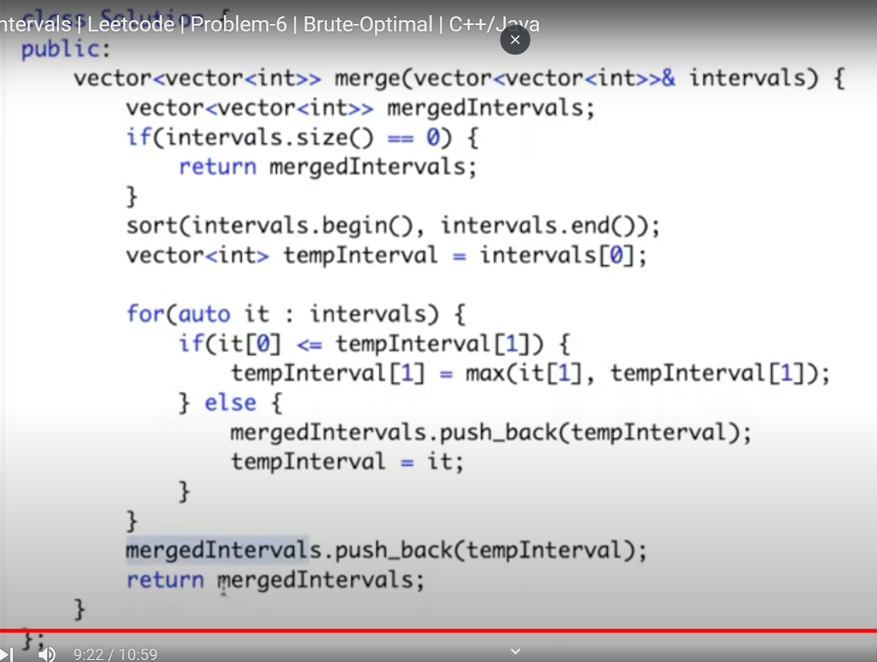

Hello Connection,  
I am glad to share that I have successfully completed the "AWS Cloud Foundation" course from [Amazon Web Services (AWS)](https://www.linkedin.com/company/amazon-web-services/).  
  
[#awsacademy](https://www.linkedin.com/feed/hashtag/?keywords=awsacademy&highlightedUpdateUrns=urn%3Ali%3Aactivity%3A6934763576163196929)

Hello Connections,  
  
I enjoyed a one of the great AWS Course then i have share successfully completed the AWS Academy Cloud Foundations Course  
[#awsacademy](https://www.linkedin.com/feed/hashtag/?keywords=awsacademy&highlightedUpdateUrns=urn%3Ali%3Aactivity%3A6934785661623230464) [#cloud](https://www.linkedin.com/feed/hashtag/?keywords=cloud&highlightedUpdateUrns=urn%3Ali%3Aactivity%3A6934785661623230464) [#certificate](https://www.linkedin.com/feed/hashtag/?keywords=certificate&highlightedUpdateUrns=urn%3Ali%3Aactivity%3A6934785661623230464) [#course](https://www.linkedin.com/feed/hashtag/?keywords=course&highlightedUpdateUrns=urn%3Ali%3Aactivity%3A6934785661623230464)